**《Fundamentals of Electric Circuits》homework CH.16**

**16.20 Find i(t) for t > 0 in the circuit of Fig. 16.43.** (15’)

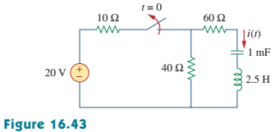

**16.44 For the circuit in Fig.16.67, find i(t) for t > 0.** (15’)

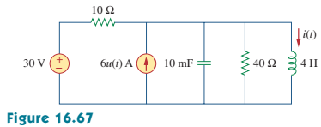

**16.57 (a) Find the Laplace transform of the voltage shown in Fig. 16.80(a).**

**(b) Using that value of *us(t)* in the circuit shown in Fig. 16.80(b), find the value of *vo(t)*.** (20’)

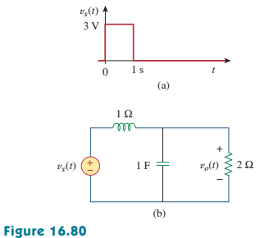

**16.69 Find *I1(s)* and *I2(s)* in the circuit of Fig. 16.92.** (20’)

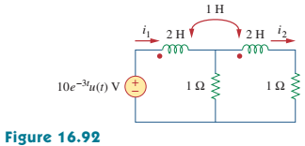

**16.75 When a unit step is applied to a system at t = 0, its response is**



**What is the transfer function of the system?** (15’)

**16.99 It is desired to realize the transfer function**



**using the circuit in Fig. 16. 108. Choose R = 1 kΩ and find L and C.** (15’)

